**Box Manufacturing Security Incident Response Playbook**

**Introduction:**

This playbook provides detailed procedures for responding to security incidents affecting Box Manufacturing, in collaboration with Cat, the MSSP consultant.

**Objectives:**

* To quickly and effectively respond to security incidents
* To minimize disruption to operations
* To communicate efficiently with all stakeholders

**Playbook Flowchart:**

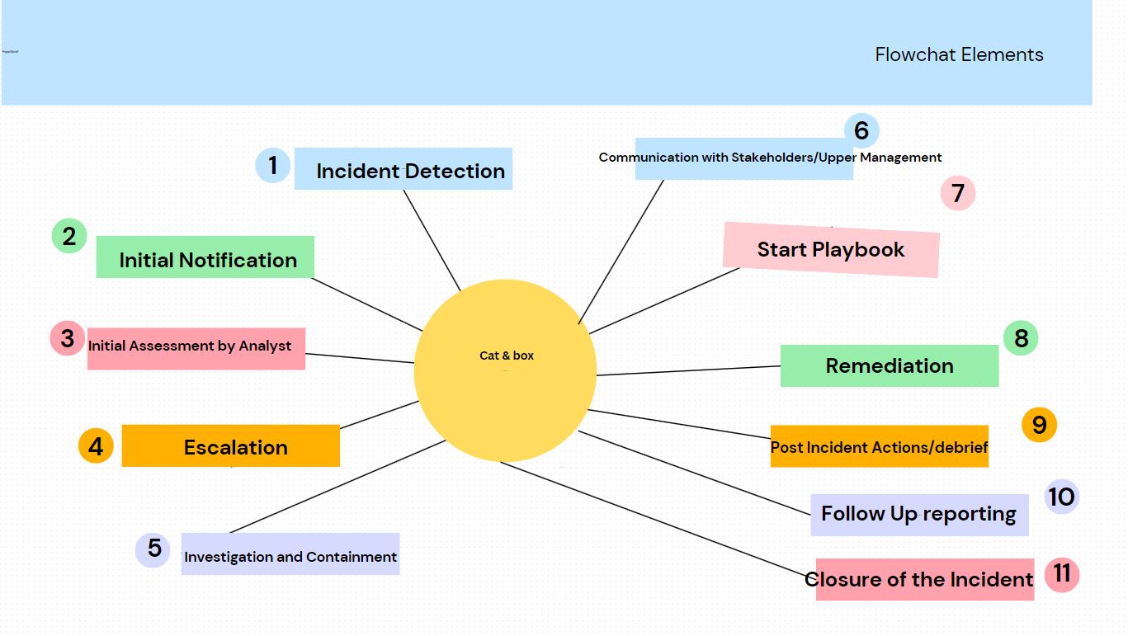

**Explanation of Flowchart:**

1. **Incident Detection**:

* Monitor for anomalies or alerts indicating potential security incidents. Employee reports of suspicious activities are also received and logged here.
* Trigger items: Anomalies or alerts from SOC monitoring tools, employee reports of suspicious activities, or notification from third parties about potential breaches

2. **Initial Notification**:

* Notify the designated contact, Misha (during business hours) or Minka (after hours/weekends), and Cat of the detected incident for preliminary assessment.
* Trigger Items: The confirmation of a potential incident by a SOC prompts immediate notification of relevant parties, such as Misha/Minka and Cat

3. **Initial Assessment by SOC:**

* Assess the credibility and severity of the incident. Determine immediate actions required and gather initial details.
* Trigger Items: The initial findings of the assessment could trigger escalation; for example, the detection of unauthorized data access or malware.

4. **Escalation**:

* If the incident is confirmed and critical, escalate to higher-level response protocols. Involve additional response teams if necessary.
* Trigger Items: A high severity rating or potential impact on critical assets or operations triggers escalation procedures.

5. I**nvestigation and Containment**:

* Carry out a detailed investigation to understand the incident. Implement measures to contain and limit the impact.
* Trigger Items: Identification of the source of the incident or significant findings during the investigation could trigger specific containment strategies.

6. **Communication with Stakeholders**:

* Continuously inform all relevant stakeholders of incident status, actions taken, and any support needed.
* Trigger Items: Key developments during the incident response, such as successful containment or identification of affected systems, trigger updates to stakeholders.

7. **Execution of Predefined Playbook (if applicable):**

* If the incident matches criteria for a predefined response (e.g., ransomware), execute the relevant steps in the specialized playbook.
* Trigger Items: This step itself may be triggered by a specific type of incident, such as ransomware, which would call for a predefined ransomware response playbook.

8. **Remediation:**

* Implement solutions to eliminate the threat, restore systems, and return to normal operations.
* Trigger Items: The completion of an investigation or understanding the full scope of the incident triggers the remediation process.

9. **Post-Incident Actions**:

* Document the incident comprehensively. Review and analyze the incident for lessons learned.
* Trigger Items: The resolution of the incident triggers a debriefing session to gather lessons learned and prepare for a post-incident report.

10. **Follow-Up Reporting**:

* Prepare and deliver an executive summary for Percy and a detailed incident report for Cat. Include actionable insights and recommendations for future prevention.
* Trigger Items: Requirements from management or regulatory bodies for reporting could be triggers, as well as the timeline completion post-incident.

11. **Incident Closure:**

* Conclude the incident response process after all actions are completed, and normal operations have resumed. Ensure all documentation is complete
* Trigger Items: The finalization of all reports and confirmation that operations have returned to normal signal the closure of the incident.

**Additional trigger Items**:

* Alerts from the SOC monitoring tools
* Employee reports of suspicious activity
* Unusual system or network performance issues
* Notification from third parties (e.g., vendors, partners) about potential breaches

**Communication Templates**:

* *To Percy*: A brief executive summary outlining the incident's impact and high-level actions taken.
* *To Cat*: A full incident report, including technical details, impact assessment, actions taken, and recommendations for future prevention.
* *To Misha/Minka*: Immediate notification of incident details, followed by regular updates as more information becomes available.

**Letter to Percy:**

**Subject**: *Executive Summary of Security Incident*

Dear Mr. Percy F.,

As per our agreed protocols, we are writing to inform you of a security incident that occurred on March 3rd, 2024. Our monitoring systems detected an unauthorized access attempt. We have taken immediate action to contain and investigate the incident.

Please be assured that our response team, led by our MSSP consultant, Cat, is working diligently to resolve this issue. We will provide a detailed report and recommendations to Cat, who will be in touch with you for further discussions. For any detailed inquiries, please direct them to Cat at [cat@soc.cat](mailto:cat@soc.cat) or by phone at 902--88-1234 (or cell 902-77-4321) for any immediate discussions.

Your operations and security are our highest priority. If you have any immediate concerns or if the incident remains unresolved after 48 hours, please do not hesitate to contact me directly at or by phone at 902-66-9999.

Sincerely,

Misha Mesha

Security Incident Manager

Box Manufactoring

Email: [mesha@box.cat](mailto:mesha@box.cat)

Phone: 902 66-9999

**Sample Letter to Cat:**

Subject: Detailed Incident Report and Action Items

Dear Cat,

Please find attached a detailed report on the security incident identified on April 1st, 2024. The report includes a comprehensive analysis of the incident, our response actions, and actionable items for remediation.

We have taken the following steps:

* Increased network monitoring to track any abnormal activity
* Implemented additional firewall rules to block the identified IP addresses
* Activated intrusion detection protocols to isolate the threat(s)

We recommend the following actions for remediation:

* Update ALL system passwords and enforce a strong password policy
* Perform detailed security audit of the entire network
* Provide additional security training to employees to recognize and report phishing attempts
* Implement a more robust data encryption method to safeguard sensitive information
* Schedule a review of all security protocols and update them as needed

For a full report and to coordinate the remediation actions, please call me at [mesha@box.cat](mailto:mesha@box.cat) or reach out to me via phone at 902-66-9999. If you need to discuss this after hours, Minka is available at [minka@box.cat](mailto:minka@box.cat) or by phone at 902-99-9999.

We appreciate your guidance on these matters and look forward to your feedback on the proposed action items.

Please confirm receipt of this report and provide any further instructions at your earliest convenience.

Best regards,

Misha P

Security Response Team Lead

Box Manufacturing

Email: [minka@box.cat](mailto:minka@box.cat)

Phone: 902 99-9999

**Closing:**

The playbook concludes with a checklist to ensure all steps have been followed, a section for documenting lessons learned, and a schedule for reviewing and updating the playbook regularly.

**Citations:**

National Institute of Standards and Technology (NIST) Special Publication 800-61

* Citation: Cichonski, P., Millar, T., Grance, T., & Scarfone, K. (2012). Computer Security Incident Handling Guide. National Institute of Standards and Technology Special Publication 800-61 Rev. 2. [**https://nvlpubs.nist.gov/nistpubs/SpecialPublications/NIST.SP.800-61r2.pdf**](https://nvlpubs.nist.gov/nistpubs/SpecialPublications/NIST.SP.800-61r2.pdf)
  + Provides guidelines on establishing an effective incident response program
* SANS Institute InfoSec Reading RoomCitation: Brown, S. (2020). Incident Handler's Handbook. SANS Institute InfoSec Reading Room. <https://www.sans.org/reading-room/whitepapers/incident/incident-handlers-handbook-33901>
  + Practical guide for incident handlers.